# Lab: Bootstrap Plugins

Problems for exercises and lab for the ["JavaScript For Front-End Course @SoftUni"](https://softuni.bg/trainings/2032/javascript-for-front-end-july-2018#lesson-8965).

You are given the **text** and the **screenshots** in **resources**.

## Collapse

Create a Web Page like the following:

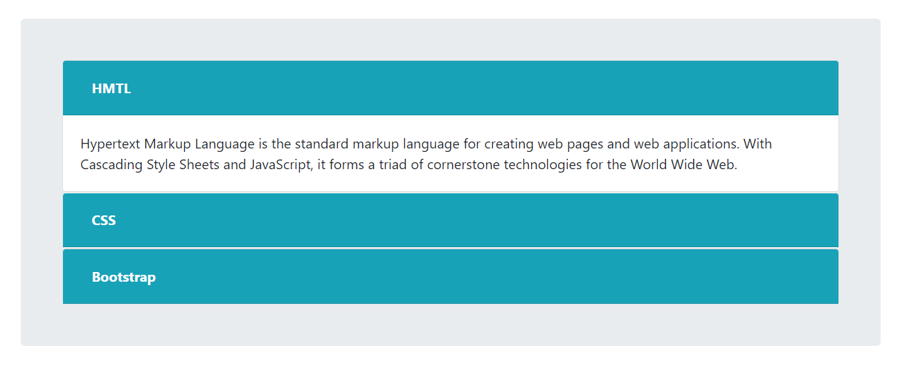

The links should **contain** text **inside** them and to **hide** and **show** it **dynamically**.

### Constraints

* Take a look at [Bootstrap documentation](https://getbootstrap.com/docs/4.1/components/collapse/)
* Do **NOT** use any custom **CSS**

## Social-Buttons

Create a Web Page like the following using **only** **Bootstrap** and [**Social** **Buttons**](https://lipis.github.io/bootstrap-social/) Plugin:

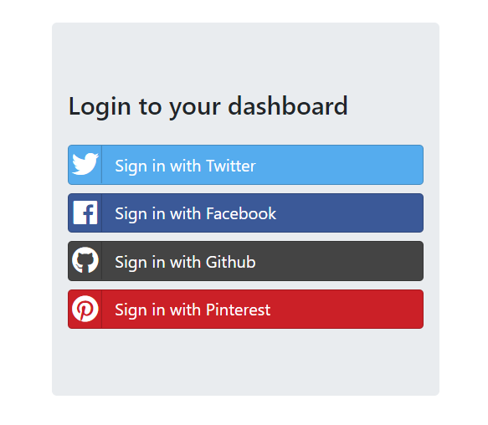

### Constraints

* You should be able to open every **hyperlink** in a **new** **tab** like the following screenshot

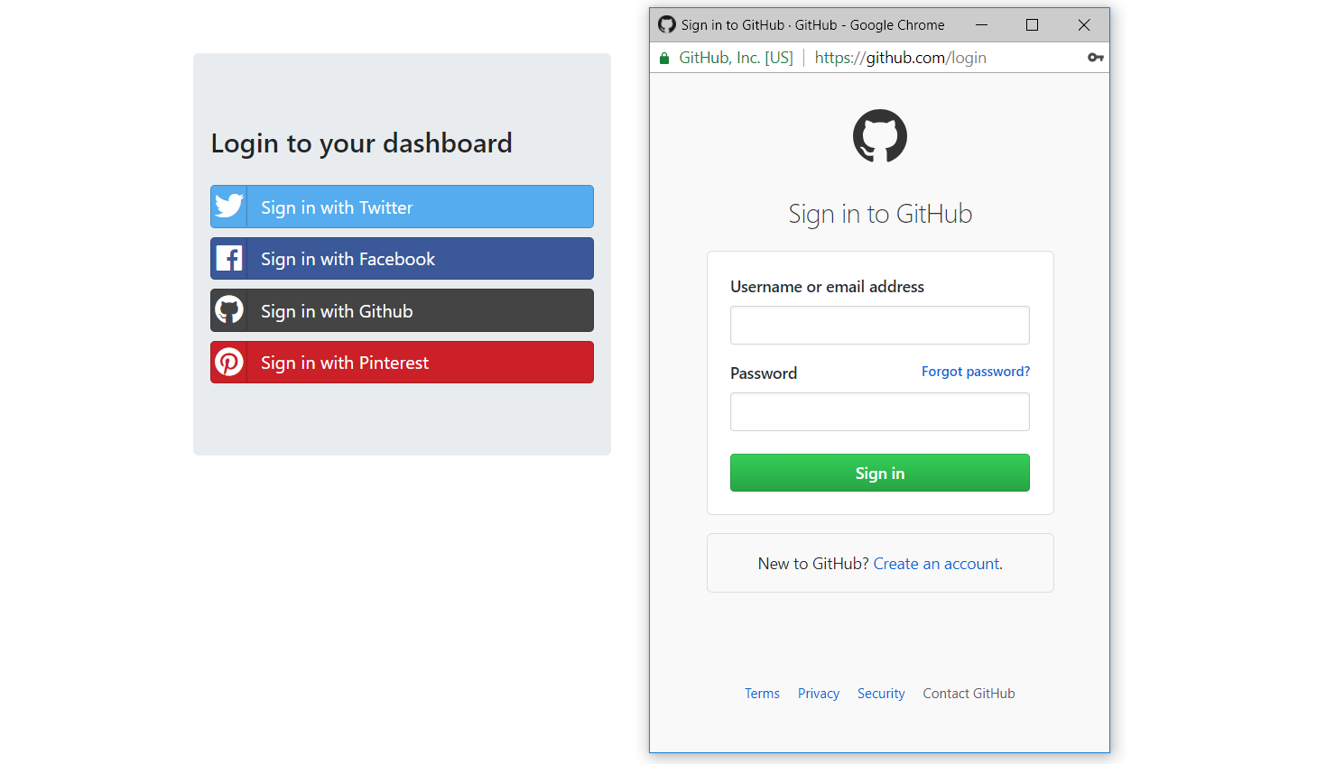

### Hints

* For attach **window.open** event look at [here](https://stackoverflow.com/questions/31539415/html-how-to-open-this-url-in-new-window)

## SweetAlert

Create a Web Page like the following using **Bootstrap** for **design**, [**SweetAlert**](https://lipis.github.io/bootstrap-sweetalert/) **Plugin** for **notifications** and somecustom **JS** for **functionality**:

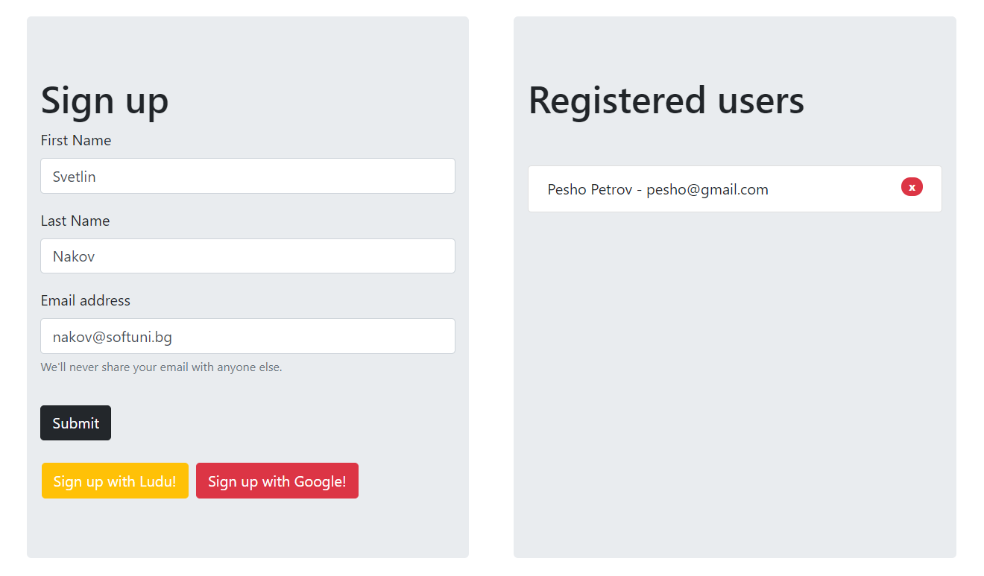

### Constraints

* You should implement the following **notifications** from **plugin:**

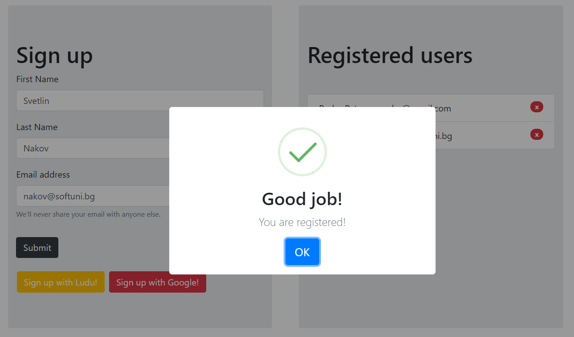

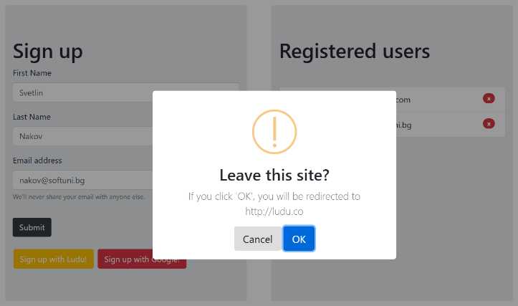 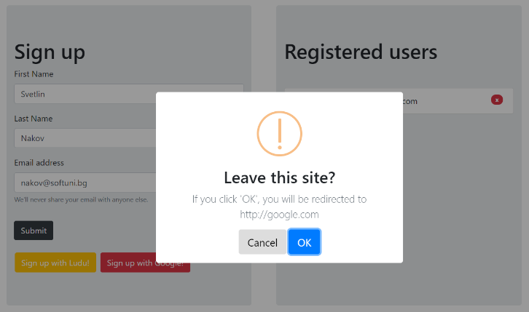

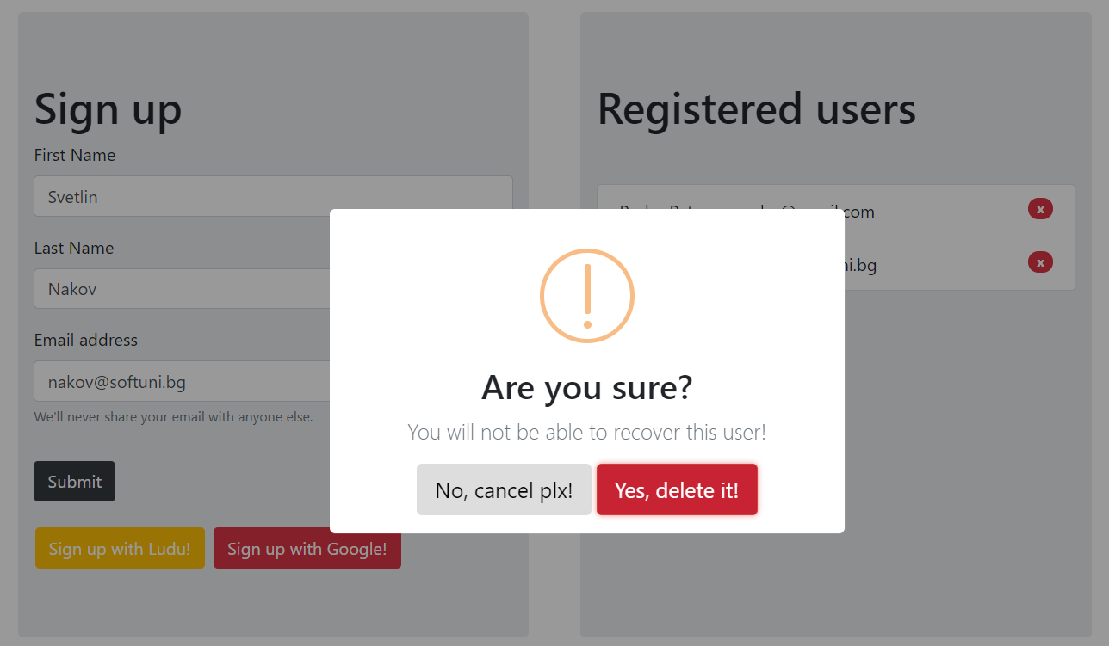

## Dropify

Create a Web Page like the following using **only** **Bootstrap** and [**Dropify**](http://jeremyfagis.github.io/dropify/) Plugin:



